79.11.05
From Frederick Bailey
RB MSS M5, Library, Royal Botanic Gardens Melbourne.

Robert St Brisbane
November 5th 1879
Dear Baron Mueller
On the 11th of last August I sent you a shoot of a supposed poison bush which I had gathered at Maroochie it was numbered 13 of the few things then sent although I could at the time neither obtain flowers or fruit I still thought you might be able to detect it from perhaps some little peculiarity of the foliage I have this day received some flower specimens and I now send you them It is now nearly 2 years since I received two fruit which I have mislaid but it was something like this —
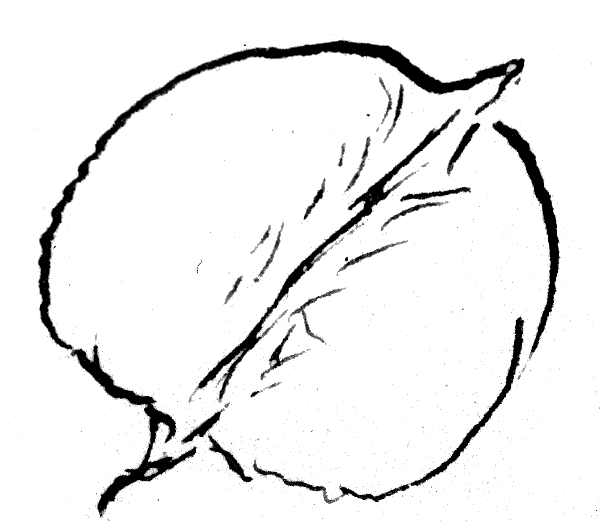
have a peach-like pubescence From the flowers now to hand I find it belongs to Proteaceae and to me seems a connecting link between the genera Helicia Lour and Macadamia F. v. Muell.
for you will observe it has an irregular perianth. very revolute segments anthers on short broad filaments, connective of medium length but very obtuse free unequal hypogynous glands The fruit had not the hard putamen of Macadamia I have no specimens of the genus Helicia Lour and in fact never saw any — The man who brought me the specimens and who also showed me the plant growing is the one who say only about half a nut nearly killed him in fact he was so ill after eating it that he had to get off his horse and lie down for some time before he could get home — Is not this a strange story about a proteace which I have always considered safe and wholesome I have read up the Flora species of Helicia but it agrees with none I would have waited and got the fruit again and than have described the plant only thought you might have a form of the genus Helicia to associate it with. For forgive me but I feel some how that you scarcely care for any things I forward unless they happen to be what you ask for — I am most grateful for all your kindness to me. My collect[ing] correspondence &c &c is for the most part done and has been done for the love of the science at my own expense — Even now as keeper of the Herbarium for which I receive a paltry pittance — I am not found in a single book I have to trust to my own poor library which thanks to Father Woods contains some good works beside I must acknowledge by indebtedness to your writings I always consider that your extensive knowledge of the flora of Australia should be taken advantage of by other workers so as to keep down as much as possible the multiplicity of names and for that reason I would much rather not name myself — By the bye I have had the other day sent to me although in a young state plants of Xanthium strumarium Linn did you know of its being in Australia notice it in the Fragmenta I think I'm right but it was loose fruit and young plants that were sent to me and they were said to be poisoning cattle
Your obediently
F M Bailey

Helicia
Macadamia
Proteaceae
Xanthium strumarium

MS found with a specimen of Helicia youngiana (MEL 93791). MS annotation by M: 'Answ 14/11/79'. Letter not found. Bailey's letter is recorded in his notebook (Notebook, Colonial Botanist, Queensland Herbarium, Brisbane) as sent on 4 November 1879.
For a summary only, see F. Bailey to M, 11 August 1879.
79-11-05_image01.jpg.
said?
i.e. those described in Flora australiensis, Bentham (1863-78), vol. 5.
then?
my?
M did not list naturalized species in his Fragmenta, but in the introduction to B83.03.04, listing Australian plants, he pointed out that 'The lines of demarcation between truly indigenous and recently immigrated can no longer in all cases be drawn with precision’ (p. viii), and included, for example, Alchemella vulgaris, which he found in the Australian Alps in the 1850s, but not Alchemella arvensis, which was first noticed near settlements. Hamilton (1892), p. 235, lists Xanthium strumarium as being known only from Qld.

